AI Blog Post Generator

N8N Automation Report
━━━━━━━━━━━━━━━━━━━━━━
SerpAPI • OpenAI GPT-4o-mini • PiAPI Flux1-dev • Google Docs

Trigger | Manual 'Test Workflow' button
Platform | N8N
Integrations | SerpAPI, OpenAI GPT-4o-mini, PiAPI (Flux1-dev), Google Docs
AI Models | GPT-4o-mini (×4 agents) + Flux1-dev (image generation)
Output | Full blog post with SEO metadata and AI hero image saved to Google Docs

Workflow Overview
Overview
This workflow automates the entire lifecycle of producing a publish-ready blog post on AI automation topics from topic discovery to final document delivery. On a single manual trigger, four chained AI agents handle topic research, content outlining, full article writing, and SEO metadata generation, each powered by GPT4o-mini with live SerpAPI web search. In parallel, a separate AI pipeline generates a custom image prompt, submits it to PiAPI's Flux1-dev image generation model, polls for completion, downloads the result, resizes it to blog hero dimensions (1340×638px), and assembles the full post SEO data, blog body, and featured image into a Google Docs document, ready for review and publishing.

1 | Pipeline Architecture Two Parallel Tracks

The workflow runs two tracks simultaneously after the SEO Metadata step:

Track | Steps
Track 1 :Content Pipeline | Best Topic → Outline → Writer → SEO Metadata (sequential, each agent builds on the previous output)
Track 2 : Image Pipeline | Image Prompt → Image Request (PiAPI) → Wait 60s → Get Image → Download Image → Edit Image (resize)

Both tracks converge at the Google Docs node, which assembles the final document combining SEO data, blog content, topic title, image URL, and formatted blog body.

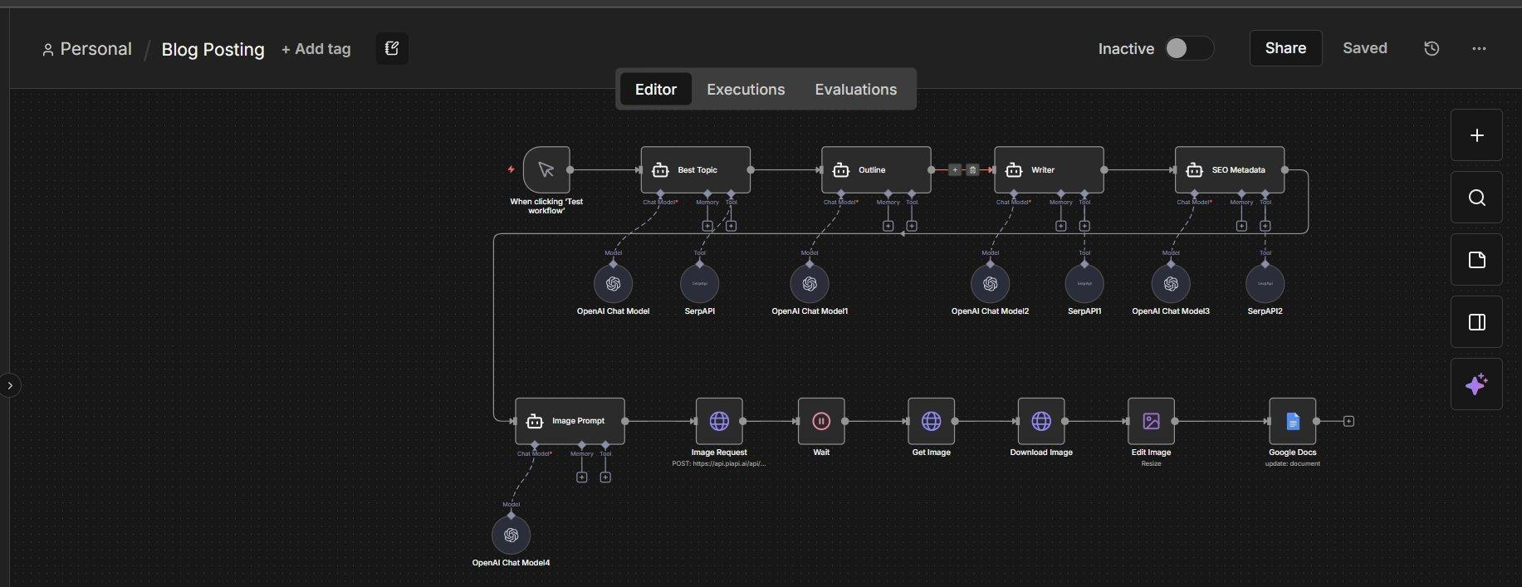

2 | How It Works Step by Step

- Step 1 : Best Topic: An AI Agent searches the web via SerpAPI for trending AI automation topics relevant to business leaders. It returns a single, timely topic title nothing else.
- Step 2 Outline: The chosen topic is passed to a second AI Agent that creates a structured 1000–1200 word blog outline: title, introduction, 4–6 section headings with bullet points, and a conclusion.
- Step 3 Writer: A third AI Agent receives both the topic and outline, uses SerpAPI for real-world research, and writes the full blog article. Output is a strict JSON object with a "title" and "blog" field, ensuring clean parsing downstream.
- Step 4 SEO Metadata: A fourth AI Agent reads the completed article and generates a meta title (max 60 chars), meta description (max 160 chars), and 5–8 SEO keywords, returned as structured JSON.
- Step 5 Image Prompt: A fifth AI Agent converts the blog topic into a high-quality image generation prompt business-tech style, no text, flat vector or semi-realistic suitable for a hero image.
- Step 6 Image Request: The prompt is submitted to PiAPI's Flux1-dev model (txt2img) at 1024×1024 resolution via HTTP POST. A task ID is returned.
- Step 7 Wait (60s): The workflow pauses 60 seconds to allow PiAPI's async image generation to complete before polling.
- Step 8 Get Image: The task status is fetched from PiAPI using the task ID. The response includes the generated image URL.
- Step 9 Download Image: The image URL is fetched as binary data, downloading the generated image into the workflow.
- Step 10 Edit Image: The downloaded image is resized to 1340×638px the standard blog hero image aspect ratio using N8N's built-in Edit Image node.
- Step 11 Google Docs: All content is assembled and inserted into a Google Docs document: SEO metadata block, raw blog JSON, formatted topic title, hero image URL, and the clean blog body text.

3 | AI Agents Roles & Models

Agent | Model | Role
Best Topic | GPT-4o-mini + SerpAPI | Finds one trending, high-value AI automation topic for business audience
Outline | GPT-4o-mini | Structures a full blog outline: intro, 4–6 headings with bullets, conclusion
Writer | GPT-4o-mini + SerpAPI | Writes complete 1000–1200 word article, outputs strict JSON {title, blog}
SEO Metadata | GPT-4o-mini + SerpAPI | Generates meta title, meta description, and 5–8 SEO keywords as JSON
Image Prompt | GPT-4o-mini | Converts blog title into a detailed Flux image generation prompt

4 | Challenges & How the Workflow Addresses Them

- Image generation via PiAPI is asynchronous the image is not ready instantly: After submitting the image request, a 60-second Wait node pauses execution before polling the task status endpoint, giving Flux1-dev sufficient time to complete generation without needing a complex retry loop.
- Downstream nodes need clean, parseable data not freeform AI text: Both the Writer and SEO Metadata agents are explicitly instructed to return strict JSON objects. This allows the Google Docs assembly node to reliably parse and insert specific fields (e.g., blog body, meta title) without ambiguity.
- Web search must be available to multiple independent AI agents: Each of the three content agents (Best Topic, Writer, SEO Metadata) is equipped with its own SerpAPI tool instance, ensuring each can independently perform live searches without sharing state or conflicting.
- Generated image dimensions must match blog hero image standards: PiAPI returns a square 1024×1024 image by default. The Edit Image node resizes it to 1340×638px a standard blog hero ratio before it is embedded in the final document.
- All content pieces are generated separately and must be assembled coherently: The Google Docs node pulls from four different upstream nodes (SEO Metadata, Writer, Best Topic, Edit Image) using direct node references, inserting each section in a structured, readable layout within a single document.

5 | Tools & Integrations

Tool / Service | Role in Workflow
OpenAI GPT-4o-mini (×5) | Powers all five AI agents: topic research, outline, writing, SEO, image prompting
SerpAPI (×3) | Live web search tool used by Best Topic, Writer, and SEO Metadata agents
PiAPI Flux1-dev | AI image generation model (txt2img, 1024×1024)
N8N Edit Image Node | Resizes generated image to 1340×638px for blog hero format
Google Docs | Final destination stores SEO data, blog body, and hero image in one document

